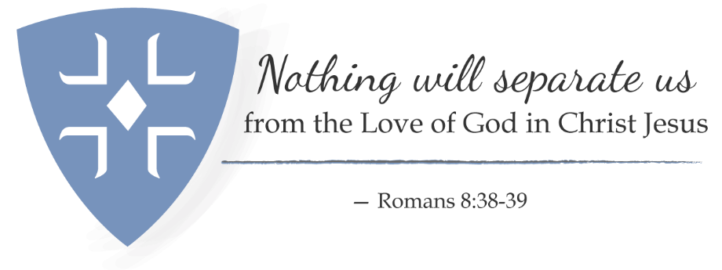

Annual Giving in [your parish]
Fall 2021

Brothers and Sisters:

We want to welcome you to our annual giving campaign for 2021. The theme this year mirrors the theme for the diocesan convention to be held in November 2021, as you see by the letterhead above.

As we have gone through the worst of the pandemic, our financial realities have been very different from what we had expected. As we begin to open our doors to our new realities, our expectations and needs may be different yet from the usual and from the recent past. We have, in our own way, striven to stay connected to one another, even as we have had to remain distant, physically. The ways in which we have connected to each other and the world around us have tested us but also brought us to the reality that “Nothing will separate us from the love of God in Christ Jesus.”

- We served ## people from our Food Pantry.
- We prepared meals for ## homeless each week.
- We continued to take flowers to nursing homes, hospitals, and shut-ins.
- We stayed in contact via phone and email with our parishioners.
- We provided ## worship opportunities each week
- Our youth were able to accomplish ---- digitally.
- We have had lower expenses in some areas and higher expenses in others (you may choose to be specific here for transparency’s sake.).
Our hope for 2022 is that we will be able to continue to provide digital worship for those who cannot join us in person. We also look to continue to serve those less fortunate than we are and perhaps expand our ministries with regard to those individuals. We hope to expand our outreach to those in the community who are less fortunate than we are. As we return to in person worship, there will be friends who will be unable to, or are too uncomfortable, to join us. We will need to reach out to them in new ways to stay connected. New fellowship ministries may need to be considered. We may also need to reach out to folks who have found us electronically and wish to stay connected that way. Opportunities are there for us if we seek them.

Our ability to stay connected to God, to one another and to the community around us may require new ways to think and act. That, in turn, may impact our budgets. We ask you to seek the places where you see yourselves connected to God through your mission and ministry in our parish, and how you and your contribution can allow you to participate in those places. Look at our current ministries and see which ones you feel are most fruitful and meet current needs in our community. Look too, to see whether ministries that have suffered during this time of pandemic are worth continuing into the future. And finally, look to see where God is calling you into future ministry in this parish. The connection we share comes first from God’s love for us all, and our willingness to do what we can to continue that connection is vital. Enclosed is a pledge card and some financial information that may help you make your decision.

We can share our connections to God and one another in our weekly communications. We can share our connection to the community around us in our outreach ministries and our ecumenical work with other bodies of faith in our area. We can prove that God’s great love is at work in our world as we seek to show that “Nothing will separate us from the love of God in Christ Jesus.”

In Christ’s love we ask:

Rector, [your church] Stewardship Chair Sr. Warden

