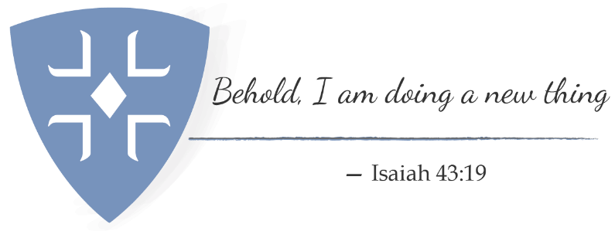

2022 Annual Giving in YOUR PARISH
Fall 2022

Brothers and Sisters:

WELCOME!

This year’s theme for diocesan convention and, hence, for annual giving is “Behold, I am about to do a new thing.” It feels like we’ve been doing nothing BUT new things during this pandemic — trying to see how mission and ministry work in that context. Now it’s time to see how we’ve been doing and see what other new things are out there.

As we have gone through the worst of the pandemic, our financial realities have been very different from what we had expected. Some of us have been able to maintain our membership, and even gain new members through our online presence. Some of us have been able to do good work which enables our physical presence with one another to feel safe. Some of us have taken “down” time to do needed maintenance in our work and worship spaces. Here is a list of things we have been able to accomplish over the last year:

- We served ## people from our Food Pantry.
- We prepared meals for ## homeless each week.
- We continued to take flowers to nursing homes, hospitals and shut-ins.
- We stayed in contact via phone and email with our parishioners.
- We provided ## worship opportunities each week
- Our youth were able to accomplish ---- digitally.
- We have had lower expenses in some areas and higher expenses in others (you may choose to be specific here for transparency’s sake.).
Our hope for 2022 is that we will be able to continue to do the new things we have begun during the pandemic – or launch new ideas that have grown out of previous ministries done in a different way. As we continue to return to in person worship, there will be friends who will be unable, or uncomfortable joining us. We will need to reach out to them in new ways to stay connected. New fellowship ministries may need to be considered. We may also need to reach out to folks who have found us electronically and wish to stay connected that way. Opportunities are there for us if we seek them.

Doing a new thing can be scary, but it can also produce new ways for us to engage in God’s work. Look at current ministries and see which ones you feel are most fruitful and meet current needs in our community. Look too, to see whether ministries that have suffered during this time of pandemic are worth continuing into the future. And finally, look to see where God is calling you into future ministry in this parish. This may be the time for you to take on something new or START something new.

All of this work will take financial commitments from each of us. Another opportunity before us is examining how much we give and whether we can do more. Enclosed is a pledge card and some financial information which may help you make your decision, as you prayerfully determine how to give back that which has been given to you.

The prophet Isaiah says “Look, I am about to do a new thing. Do you not perceive it?” This time of annual giving, which coincides with the beginning of the program year for so many of us, is a time to take stock. Do you not perceive it?

In Christ’s Love we ask:

Rector, Your church Stewardship Chair Sr. Warden

